<https://qc2web1/web/selAcctProjLocn.php?name=Users%20Info&script=user_contact.php>

Call the following page.

Al enviar como parametron user_contact.php esta pagina es para muchos y el parámetro redirecciona a donde ir.

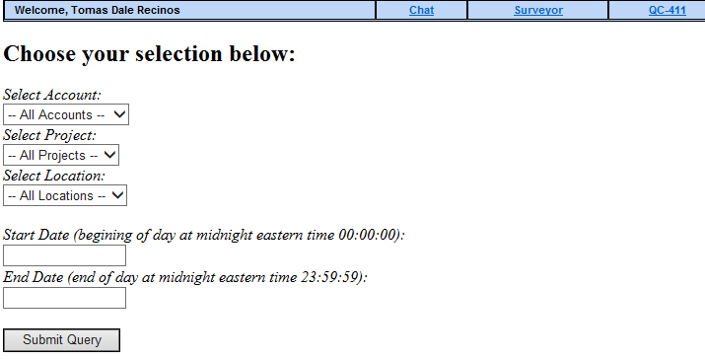

<?php

require('common/main.php');

generateHeader("QuickConnect");

$acct = getAccountList();

?>

<link href="stylesheet/calendar.css" rel="stylesheet" type="text/css"/>

<script type='text/javascript' src='js/calendar.js'></script>

<script type="text/javascript">

function onAcctChange(list) {

var idx = list.selectedIndex;

var acct = list[idx].value;

document.inp.projId.options.length = 1;

document.inp.projId.options[0] = new Option("-- All Projects --", "0", true, false);

if (acct > 0) {

document.getElementById('projLbl').firstChild.data = "Select Project (Populating List.. Please wait):";

ajaxGet("jGetProjs.php?acctId=" + acct, function(data) {displayProjs(data);});

}

}

function displayProjs(data) {

var result = eval('(' + data + ')');

document.inp.projId.options.length = 0;

document.inp.projId.options[0] = new Option("-- All Projects --", "0", true, false);

document.getElementById('projLbl').firstChild.data = "Select Project:";

for (i=0; i<result.length; i++)

document.inp.projId.options[document.inp.projId.options.length] = new Option(result[i].name, result[i].id, false, false);;

}

function onProjChange(list) {

var idx = list.selectedIndex;

var proj = list[idx].value;

document.inp.locnId.options.length = 1;

document.inp.locnId.options[0] = new Option("-- All Locations --", "0", true, false);

if (proj > 0) {

document.getElementById('locnLbl').firstChild.data = "Select Location (Populating List.. Please wait):";

ajaxGet("jGetLocns.php?projId=" + proj, function(data) {displayLocns(data);});

}

}

function displayLocns(data) {

var result = eval('(' + data + ')');

document.inp.locnId.options.length = 0;

document.inp.locnId.options[0] = new Option("-- All Locations --", "0", true, false);

document.getElementById('locnLbl').firstChild.data = "Select Location:";

for (i=0; i<result.length; i++)

document.inp.locnId.options[document.inp.locnId.options.length] = new Option(result[i].name, result[i].id, false, false);;

}

</script>

<h2>Choose your selection below:</h2>

**<form name="inp" action="<?php print $_GET['script']; ?>">**

<i>Select Account:</i><br>

<select name="acctId" onChange="onAcctChange(this);">

<option value="0">-- All Accounts --</option>

<?php

foreach($acct as $val => $name)

print "<option value=\"$val\">$name</option>";

?>

</select>

<br>

<i id="projLbl">Select Project:</i><br>

<select name="projId" onChange="onProjChange(this);"><option value="0">-- All Projects --</option></select>

<br>

<i id="locnLbl">Select Location:</i><br>

<select name="locnId"><option value="0">-- All Locations --</option></select>

<br>

<?php if ($_GET['qcav'] != "") { ?>

<br>

<i>Select Type:</i>

<br>

<select name="qcav">

<option>Both</option>

<option>LiveView</option>

<option>QuickView</option>

</select>

<br>

<?php } ?>

<?php if ($_GET['qcav_sum'] != "") { ?>

<br>

<i>Summary:</i>

<br>

<select name="qcav_sum">

<option>None</option>

<option>Include</option>

<option>Only</option>

</select>

<br>

<?php } ?>

<?php if ($_GET['time_dur'] != "") { ?>

<br>

<i>Summary:</i>

<br>

<select name="time_dur">

<option>Minutes</option>

<option>Hours</option>

</select>

<br>

<?php } ?>

<?php if ($_GET['singledate'] != "") { ?>

<br>

<i>Date (begining of day at midnight eastern time 00:00:00):</i><br>

<input name="sDate" type="text" maxlength="15" size="15" onfocus="cal.showCal(this);" />

<br>

<?php } ?>

<?php if ($_GET['dateRange'] != "") { ?>

<br>

<i>Start Date (begining of day at midnight eastern time 00:00:00):</i><br>

<input name="sDate" type="text" maxlength="15" size="15" onfocus="cal.showCal(this);" />

<br>

<i>End Date (end of day at midnight eastern time 23:59:59):</i><br>

<input name="eDate" type="text" maxlength="15" size="15" onfocus="cal.showCal(this);" />

<br>

<?php } ?>

<?php if ($_GET['detailed'] != "") { ?>

<br>

<i>Detailed:</i>

<br>

<select name="detailed">

<option>No</option>

<option>Yes</option>

</select>

<br>

<?php } ?>

<br>

<input type="submit"/>

</form>

<?php generateFooter(); ?>